**APPENDIX**

**1) Displaying ARPABET phoneme in console:**

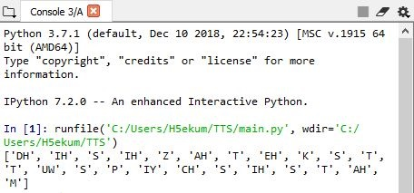 The result of the above program is displayed in the console of Spyder IDE that we used for python programming to create a TTS system. In the figure below, the user enters the word or a phrase. Then the program converts the word into the equivalent phonemes by searching in the 'cmudict-0.7b.txt' and then the sound of each phonemes are concatenated together with the help of pyaudio. The sounds are extracted from the folder where sounds of each phonemes are stored.

Fig: Phonemes displayed in console

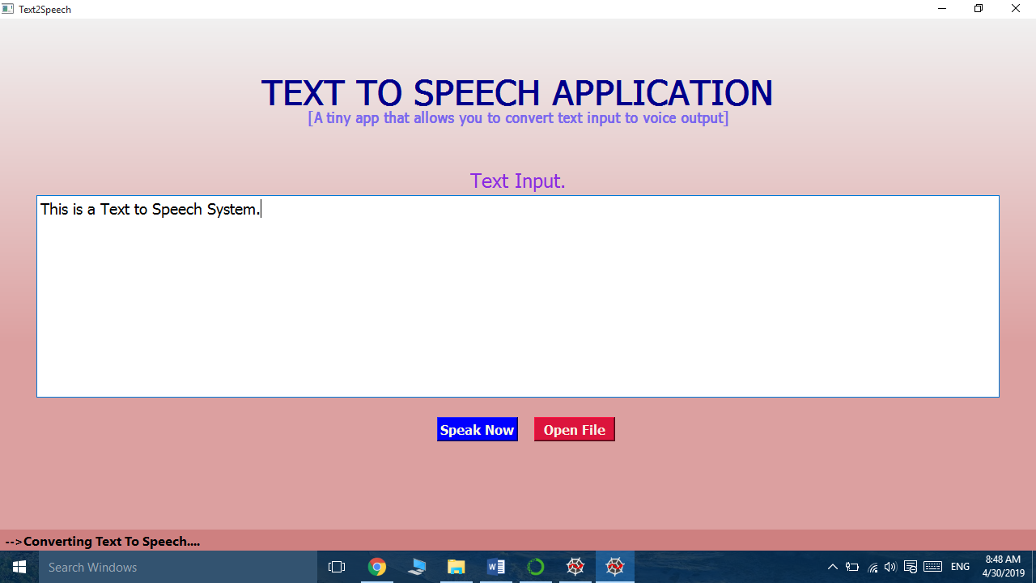**2) GUI of TTS System:**

Fig: GUI of TTS System

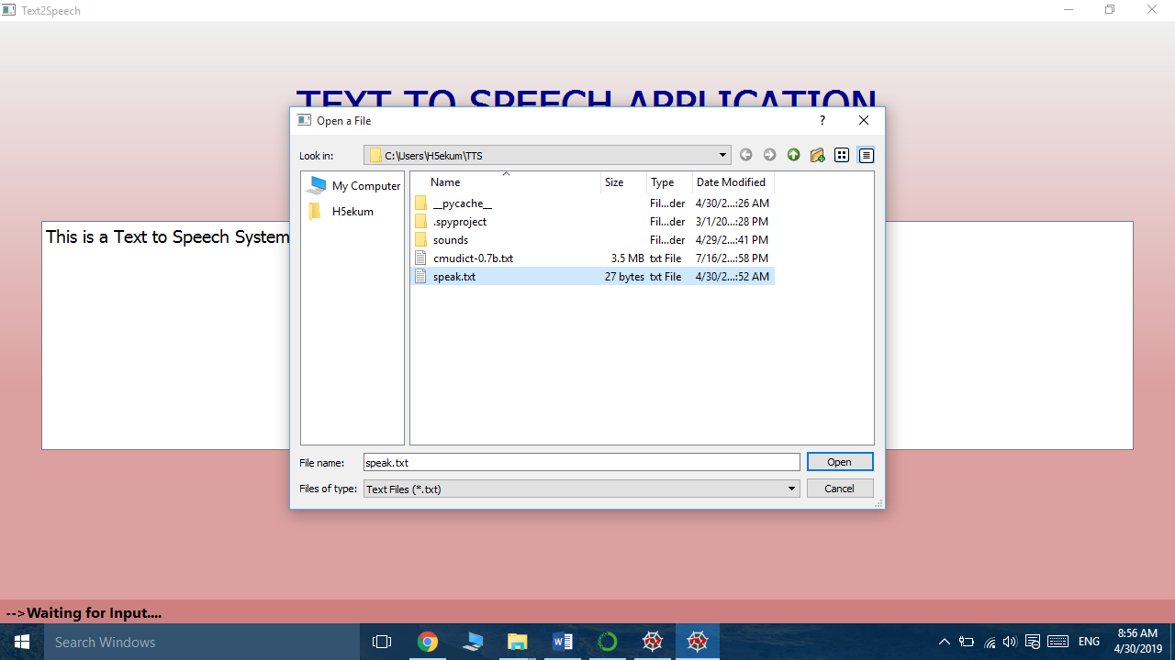The graphical user interface for the system is shown in the figure 4.1.2. The interface consists of interactive elements. The text edit box is used to input the text and two buttons in the system are used to perform a specific actions. When “Speak Now” button is clicked the system converts the text to speech. When “Open File” button is clicked it opens a dialog box to select the file as show in the figure below:

Fig: Opening a file

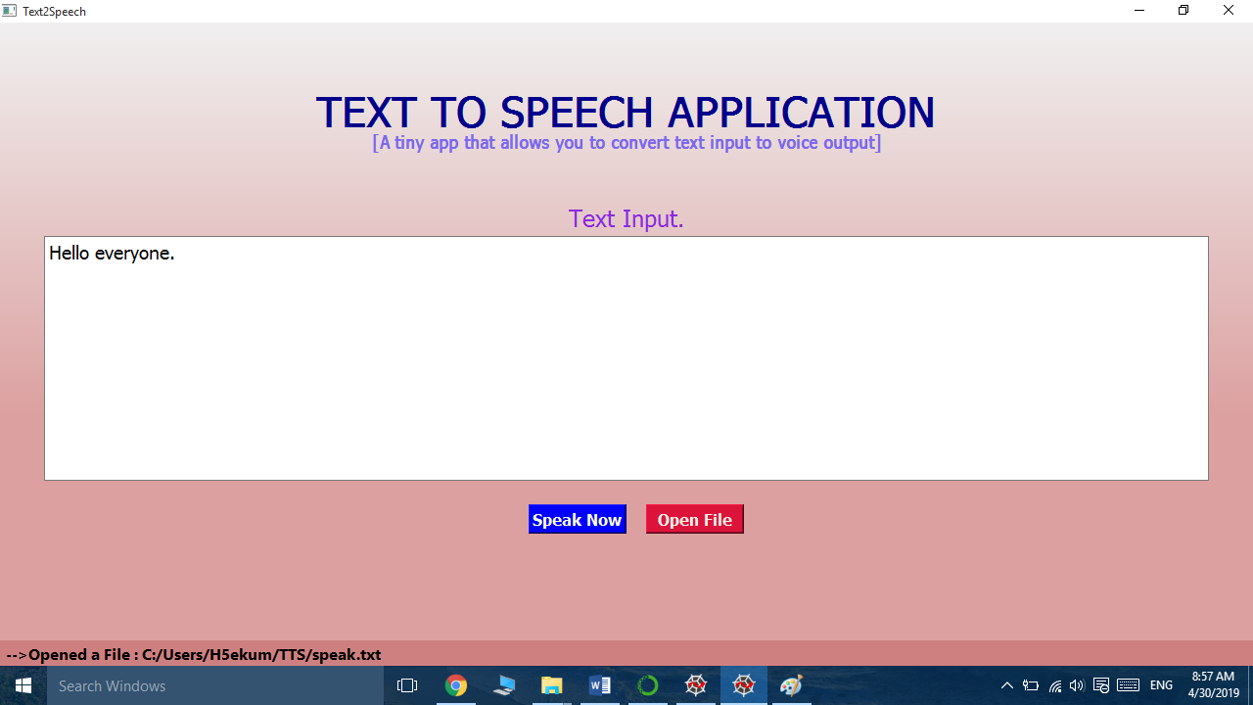After the file has been selected and “Open” button in the dialog box is clicked, then the content of the selected dialog box is displayed on the text edit box as show in the figure below:

Fig: Displaying the content of selected txt file